DevOps Project Management

Docker

In this lab we will install Docker and Docker Compose on a Linux virtual machine. This will prepare us for more complex tasks using Dockerfiles in later labs.

Contents
1 Docker Basics 2
1.1 Independent Student Activity 3
1.1.1 Copy text from PC to VM 3
2 Download Docker 4
2.1 Option 1: Download Docker via command line 4
2.1.1 Docker Community Edition 5
2.1.2 Docker Compose on Ubuntu 7
2.1.2.1 Download Docker Compose 7
2.2 Option 2: Download Docker via Ubuntu Software 9
2.2.1 Add user account to the docker group 10
2.2.2 To create and start a container made from a Debian image type 10
3 Remove Docker 11
4 Independent Student Activity 12
5 Appendix A: Errors installing 12

- Docker Basics
Docker is a set of products which provides a mechanism of containerising software, so that the required elements of the operating system can be contained with the software application. This gives an advantage over virtual machines, which have significant system requirements in comparison to containers. Containers need only the required libraries or binary files, rather than the full operating system. In this way containers are often a few MBs in size whilst VMs are often GBs in size. Containers are supported in Linux based operating systems, while support for containers is still new and somewhat limited in Windows.
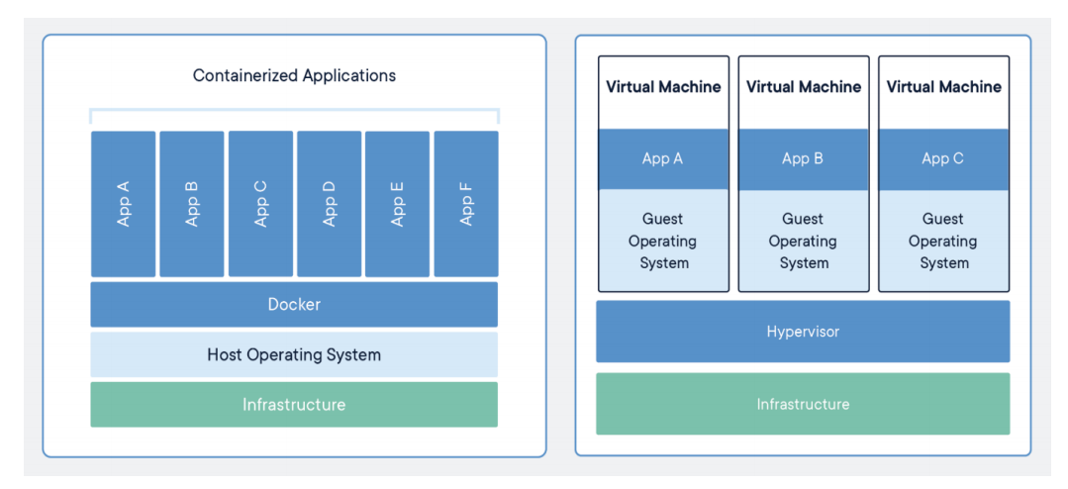
Figure 1: Docker versus Virtual Machine(VM)
Figure 2 shows a high-level overview of the Docker Architecture. The container is a list of
packages, dependencies and libraries which can be used to host your application. The container
is created from a template referred to as an image. Images can be pulled from the registry so that a copy is held locally for use.

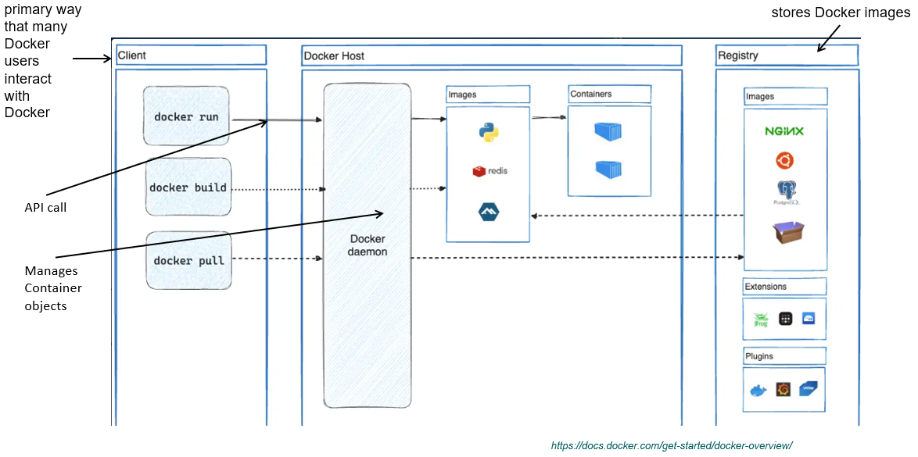
Figure 2 : Docker Architecture
To ensure that Docker does not clash with other software such as VirtualBox or VMware work- station we will run docker inside a virtual machine. This lab demonstrates Docker used on an Ubuntu VM using VMWare Workstation.
  - Independent Student Activity
Download Ubuntu Server or Desktop from the website. If using server you will have a very small VM with only a command line interface which is fine for this lab. If using Desktop, the VM will be larger and you will have a graphic interface (but we will work in the command line). Use the Long Term Service (LTS) version even though later versions may be available.

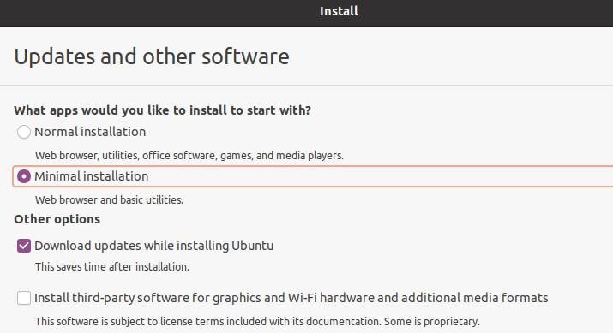
Figure 3: Using VMWare download a minimal installation of Linux Ubuntu
Once a Linux Ubuntu VM setup and logged in, then we must download Docker.

Do not do use the Ubuntu installation process: It is possible to select Docker and MicroK8s when installing Ubuntu Server later labs. This is not demonstrated here as we are using Ubuntu Minimal Desktop.

    - Copy text from PC to VM
If using VMware, here is a handy way to copy text from your PC to the VM box:
If using VMware install vmware tools as it will make copying commands from this document a little easier:

sudo apt-get install open-vm-tools
sudo apt-get install open-vm-tools-desktop

- Download Docker
There are a few ways to install Docker. The first is using the command line and another way uses Ubuntu Software Installer (suitcase icon) to install Docker.

  - Option 1: Download Docker via command line
The instructions provided here are adapted from those found on the Docker website. The installation is carried out on an Ubuntu VM as shown.

Begin by updating the APT repository:

sudo apt-get update

APT (Advanced Package Tool) is a package manager with a repository or database of the available packages. A number of useful packages include:
- apt-transport-https(allows the use of repos access by https)
- ca-certificates(holds up-to-date certificates that are common to everyone)
- curl(for downloading/transferring data)
- gnupg-agent (daemon for managing secret keys)
- software-properties commons(manages repositories that software can be installed from).

Install these packages by typing:
sudo apt-get install apt-transport-https sudo apt-get install ca-certificates
sudo apt-get install curl

sudo apt-get install gnupg-agent
sudo apt-get install software-properties-common

Check the following folder exists
ls -al /etc/apt/keyrings

If it does not exist, then make this directory by typing:
sudo mkdir -p /etc/apt/keyrings
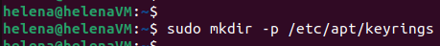

Once curl is downloaded the GPG key can be downloaded. GPG keys are used to encrypt and decrypt data. If this worked a new key should be in the keylist. To confirm, type the fingerprint command below.
curl -fsSL https://download.docker.com/linux/ubuntu/gpg | sudo gpg --dearmor -o /etc/apt/keyrings/docker.gpg
Add a stable release
sudo add-apt-repository "deb [arch=amd64] https://download.docker.com/linux/ubuntu $(lsb_release -cs) stable"

Note: If you have any problems or issues with downloading the stable release refer to Appendix A.

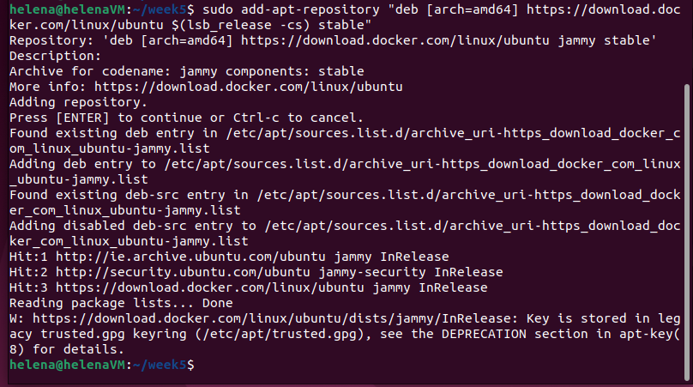

Run the update again just to be sure everything is updated
sudo apt-get update
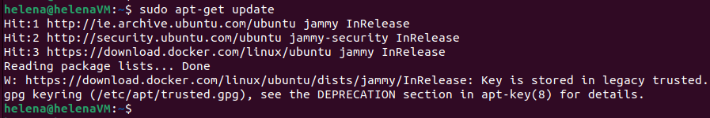

This repository is added as a base. No beta builds are required for this course/module. Update file information from the repository.
If you have an error in the repository you can clean it using the software updates in a GUI editor or edit the list file directly using
sudo apt install gedit
sudo –H gedit /etc/apt/sources.list

    - Docker Community Edition
Docker Community Edition (CE) provides a standard runtime environment for containers with a common API and CLI. Install Docker community edition:
sudo apt install docker-ce

Run a basic container to check that it is working
sudo docker run hello-world
It checks if the HelloWorld image is available locally and it is not as we do not have any images at the min. So it then checks the remote repository and pulls from the library HelloWorld image. If it works you should get a message explaining how Docker generates your container.
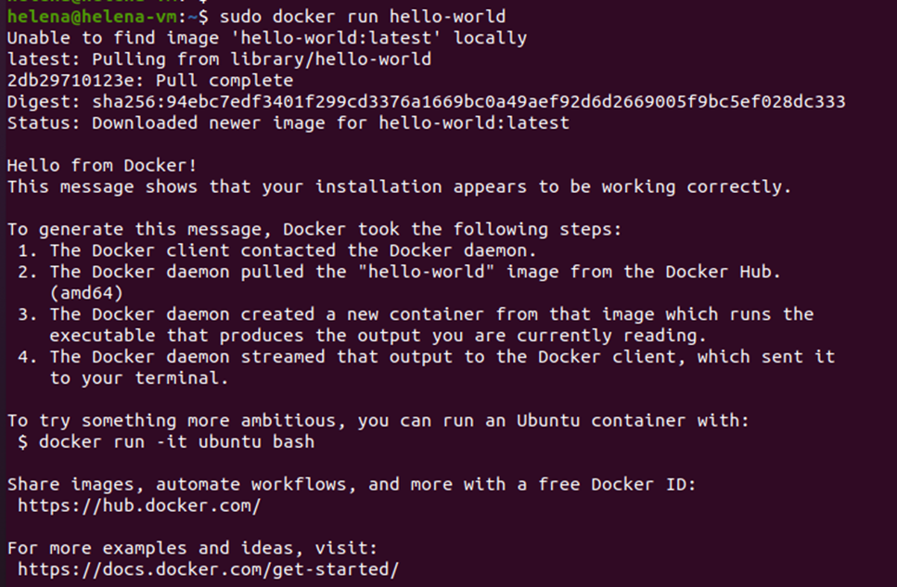

    - Docker Compose on Ubuntu
Docker Compose is a tool for defining and running multi-container applications. It is the key to unlocking a streamlined and efficient development and deployment experience. With Docker Compose you use a YAML configuration file, known as the Compose file, to configure your application’s services, and then you create and start all the services from your configuration with the Compose CLI.
Compose works in all environments; production, staging, development, testing, as well as CI workflows. It also has commands for managing the whole lifecycle of your application:
- Start, stop, and rebuild services
- View the status of running services
- Stream the log output of running services
- Run a one-off command on a service

Docker Compose is a tool to use Compose file, yaml file - compose.yaml, which creates and configures docker containers.
The Docker CLI lets you interact with your Docker Compose applications through the docker compose command, and its subcommands. Using the CLI, you can manage the lifecycle of your multi-container applications defined in the compose.yaml file. The CLI commands enable you to start, stop, and configure your applications effortlessly.

As per Docker’s own definition, Docker Compose uses a 3 step process:
- “Define your app’s environment with a Dockerfile so it can be reproduced anywhere.
- Define the services that make up your application in compose.yaml so they can be run together in an isolated environment.
- Run docker-compose up and Compose starts and runs your entire app.”2

      - Download Docker Compose
The following command uses curl to download the latest version of docker compose. The command is long so be careful when copying it. Watch for spacing and the backquote which is found on the upper left of the keyboard. This is different to the ordinary quote found on the right of the keyboard.
- uname –s provides the kernel
- name (Linux) uname –m provides the machine name (x86_64)

sudo curl -L https://github.com/docker/compose/releases/tag/v2.32.0/docker-compose-`uname -s`-`uname -m` -o /usr/local/bin/docker-compose

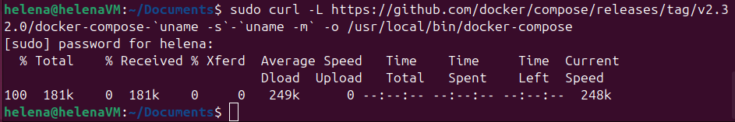

Make the docker compose folder executable by applying the chmod command:
sudo chmod +x /usr/local/bin/docker-compose

Verify the version of compose to ensure the installation is complete:
docker --version

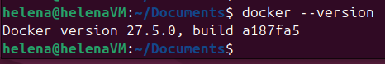

Lastly, add the user account to the docker group. In this example the user is logged in as helena.
sudo usermod -aG docker helena

The change doesn’t occur until the user logs out and logs back in again. You will get errors later if you do not log out and log back in again. Check if you have the docker group in the list for the account by typing
groups
Or
getent group

At this point you could take a snapshot of the Ubuntu Virtual Machine that you are working on. This becomes a safe restore point where the required software is installed. It is also recommended that you take a clone of the VM if you have room on your external hard-drive.

We do not require Docker to start when booting the system. If we did, we would run:
sudo sytemctl enable docker

If you reboot the virtual machine you might need to restart the Docker service:
Check if the service is running
sudo systemctl status docker.service

Start the service if needed using:
sudo systemctl start docker.service

Some useful commands that can be entered at the $ prompt after exiting the container:

Table 1: Useful command to manage containers
Command | Description
exit | Exit from inside the container
docker images | List the images currently available
docker ps | List any running containers
docker ps -a | List any containers that are stopped – the container we just stopped should display
docker start xxxx | Restart a container, where xxxx is container ID or first few chars of the container ID
docker attach xxxx | Get back into the bash session within the container, where xxxx is the container ID
  - Option 2: Download Docker via Ubuntu Software
Docker can also be installed Ubuntu Software Installer (suitcase icon). Open Ubuntu Software Installer, search for docker and click install(Figure 4).
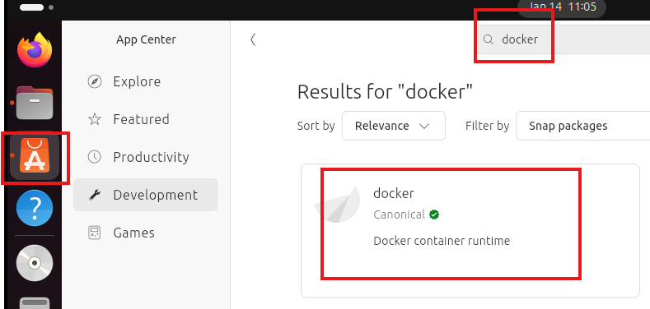
Figure 4: Download Docker via Ubuntu Software

Information about the software is provided on this screen(Figure 5), including how popular it is and how to use it. You should always read this information as the software provides a method to access Docker. Where Docker is installed and what default settings were chosen will be important later.
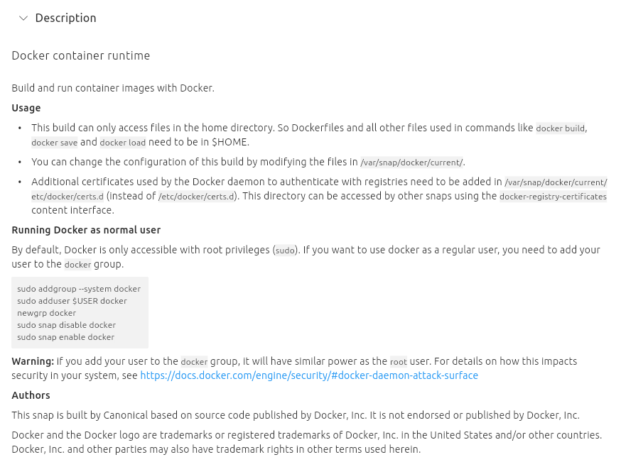
Figure 5: Docker container runtime details

As this version is installed it can only access files in the home directory. Dockerfiles and other files used in commands such as docker build, docker save and docker load need to be held in the home directory. To change the configuration, modify the files in /var/snap/docker/current.

    - Add user account to the docker group
Search for and open a command window (terminal) to add the user account to the docker group. Click the ‘Show Applications’ icon in the bottom left of the screen and type Terminal in the search box.

The command provided in the instructions on the installation screen are typed in. This was shown when selecting Docker from the software installer. Enter the commands as shown below.

By default, Docker is only accessible with root privileges (sudo). If you want to use docker as a regular user, you need to add your user to the docker group.(Figure 6)
sudo addgroup --system docker
sudo adduser $USER docker
newgrp docker
sudo snap disable docker
sudo snap enable docker
Warning: if you add your user to the docker group, it will have similar power as the root user. For details on how this impacts security in your system, see https://docs.docker.com/engine/security/#docker-daemon-attack-surface

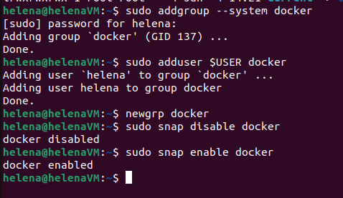
Figure 6: Add user account to the Docker group
Note: Debian is an operating system which is composed primarily of free and open-source software, most of which is under the GNU General Public License, and developed by a group of individuals known as the Debian project. Debian is one of the most popular Linux distributions for personal computers and network servers, and has been used as a base for several other Linux distributions.

    - To create and start a container made from a Debian image type
Create and start a container using the below command in terminal:

sudo docker run -it --name=helenasdeb debian

(“helenasdeb” Call this any name you like, e.g. your own name)
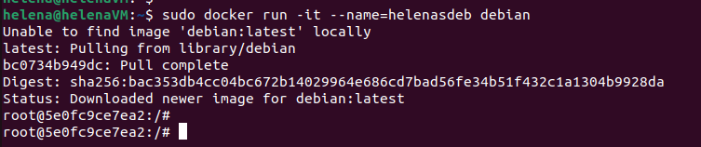
Figure 7: Create and start a container from Debian image
In this example we create a container named helenasdeb (Figure 7) which is made from the Debian image. We want the latest version but we could have described a specific build number if preferred.
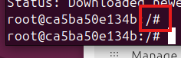
Figure 8: changed command prompt
Note: the change in the command prompt (Figure 8) - this shows us that we are ‘in’ the container, isolated from the main OS. This is bare minimum container for the OS, so there is very little functionality here only what is defined in the image that we just created our container from.

The change of prompt from $ to # also gives a hint - however if we had chosen to run an Ubuntu container the prompt would not change.

- Remove Docker
Via command line:
sudo apt-get remove docker docker-engine docker.io containerd runc

Via Software Store (if installed this way):
Go to Software Store, search for Docker, click in the green down arrow button
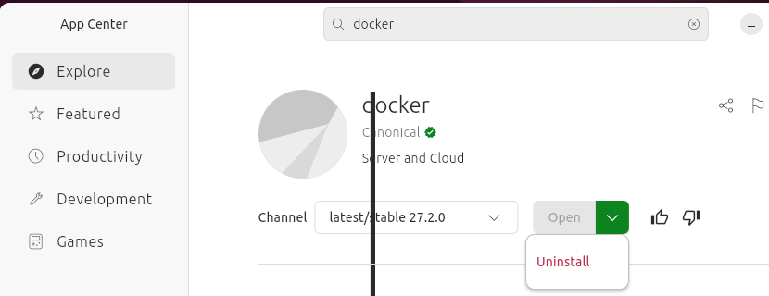
Figure 9: UNinstall via Software Store
- Independent Student Activity
Review and implement at least one of the Docker Compose samples found at this Github directory.

- Appendix A: Errors installing
If there is an error similar to below when attempting to download a stable release
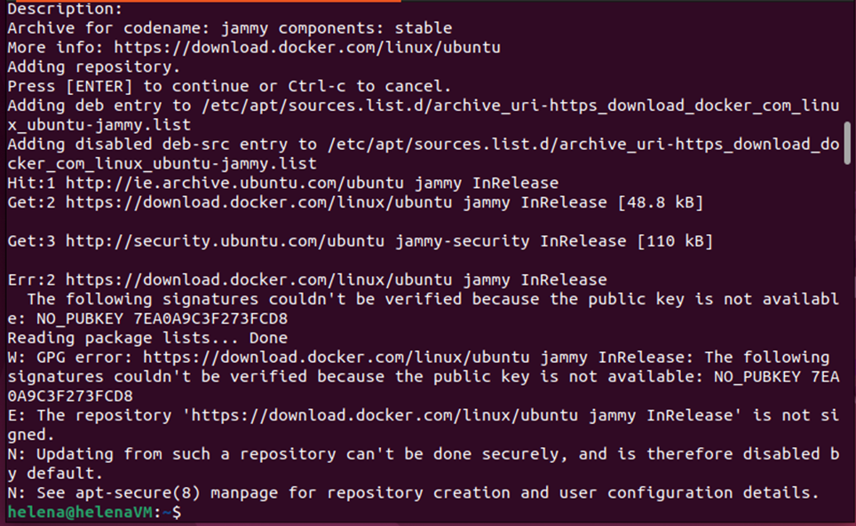

Use the following to resolve:
sudo apt-key adv --keyserver keyserver.ubuntu.com --recv-keys 7EA0A9C3F273FCD8
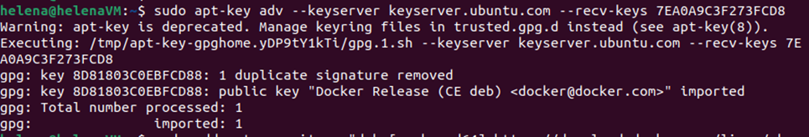

Then re-run the command to get a stable release:
sudo add-apt-repository "deb [arch=amd64] https://download.docker.com/linux/ubuntu $(lsb_release -cs) stable"
